PROJECT REPORT
Supply Chain Analysis - Power BI

Submitted by: Jenihelan M
Project id: PTID-CDA-MAR-26-1371
Project Code: CDACL - 003
Date: 20.04.2026

CHAPTER – 1: INTRODUCTION

  - Introduction
This project focuses on analyzing supply chain data to evaluate business performance across multiple areas such as sales, inventory, delivery, and product quality. The aim is to identify patterns, inefficiencies, and opportunities for improvement using data visualization techniques.
A Power BI dashboard was developed to provide a clear and interactive view of key supply chain metrics, enabling better decision-making.
  - Objectives of the Study
- To analyze product-wise sales and revenue performance.
- To evaluate inventory and stock management efficiency.
- To study delivery performance using shipping and lead times.
- To assess supplier performance based on defect rates and costs.
- To generate meaningful insights and business recommendations.

  - Scope of the Study
- Covers analysis of supply chain data including sales, inventory, delivery, and quality.
- Focuses on product categories such as Haircare, Skincare, and Cosmetics.
- Includes supplier performance analysis using a separate dataset.
- Uses Power BI dashboard for visualization and comparison.

  - Limitations of the Study
- The supplier information is present in two different tables with inconsistent naming conventions. In the main dataset, suppliers are labeled as Supplier 1, Supplier 2, etc., while in the supplier performance dataset, they are labeled as Supplier A, Supplier B, and Supplier C. Due to this mismatch, a direct relationship between the tables could not be established, and supplier analysis was performed separately.
- The dataset is limited in size and may not reflect real-world complexity.
- No time-based analysis due to absence of date-related fields.
- Inspection results are not directly linked to supplier performance.

CHAPTER – 2: METHODOLOGY

2.1 Data Source
The dataset was extracted from a MySQL database using phpMyAdmin. The data was then exported in CSV format and imported into Power BI for analysis.

2.2 Dataset Description
The dataset includes various attributes related to supply chain operations such as:
- Product Type, SKU, Price
- Revenue Generated, Number of Products Sold
- Stock Levels, Availability
- Shipping Time, Lead Time
- Supplier Name, Location
- Manufacturing Cost, Defect Rate
- Inspection Results
- Transportation Mode and Shipping Cost

2.3 Data Preparation and Cleaning
- The dataset was imported into Power BI from a CSV file.
- Basic data validation was performed to ensure consistency and correctness.
- Split merged data into two tables:
- Supply Chain Data
- Supplier Performance Data
- Created calculated column:
Stock Status (Low Stock / Sufficient Stock)
- Created measures:
- Total Revenue
- Total Products Sold
- Average Shipping Time
- Average Defect Rate

2.4 Tools and Technologies Used
- Power BI – Data visualization and dashboard creation.
- PhpMyAdmin – Used to access and export the dataset.
- CSV – Data format used for analysis.
2.5 Steps in Analysis
- Data collection from database.
- Data cleaning and transformation.
- Data modeling and table separation.
- Creating visualizations using charts and KPIs.
- Generating insights and business recommendations.

2.6 Dashboard Design
- The dashboard was designed with five main pages:
- Overview
- Sales Analysis
- Inventory Analysis
- Delivery Analysis
- Quality Analysis
- Each page includes interactive visuals and slicers to enhance user experience and analysis.

CHAPTER -3: ANALYSIS

3.1 Dashboard Overview
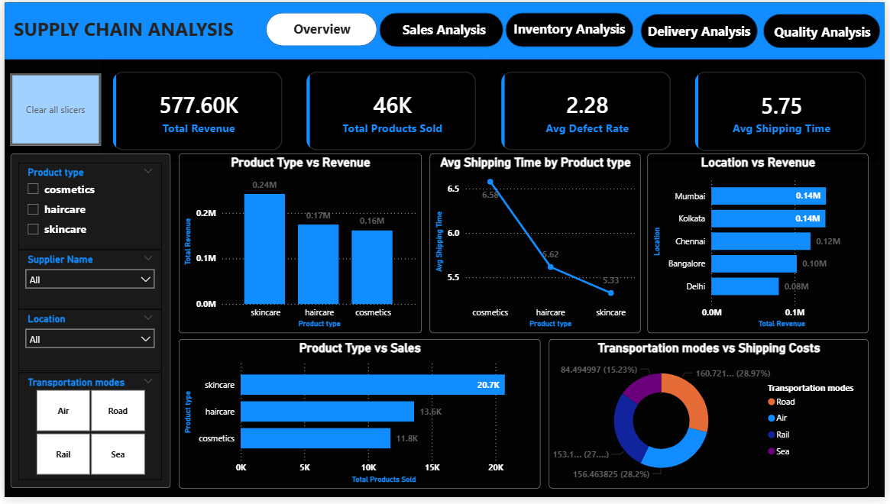
Fig 1.1
Overview Dashboard – Insights:
The overview dashboard highlights the overall performance of the supply chain across products, locations, and logistics.
- The business generated a total revenue of 577.60K with approximately 46K products sold, indicating strong overall performance.
- Skincare products are the top-performing category, contributing the highest revenue (~0.24M) and sales (~20.7K units), showing strong customer demand.
- Cosmetics products experience higher shipping time of (6.58 days) compared to other categories, indicating delivery inefficiencies.
- Mumbai and Kolkata are the highest revenue-generating locations, while Delhi shows comparatively lower performance.
- In terms of logistics cost, Road (~29%) and Air (~28%) contribute the highest share of shipping cost, whereas Sea (~15%) is the most cost-efficient mode.

3.1.1 Sales Analysis
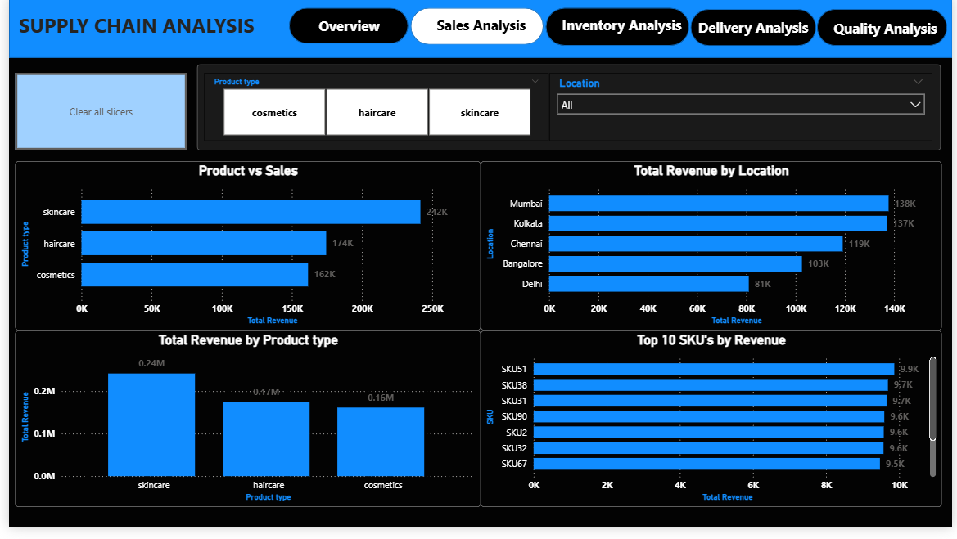
Fig 1.2

SALES ANALYSIS – Insights:
Focus: This analysis focuses on understanding product and regional sales performance.
- Skincare products dominate both sales and revenue, while haircare shows moderate performance and cosmetics contribute the least.
- A strong relationship is observed between sales volume and revenue, indicating that higher demand directly drives revenue growth.
- Revenue distribution across locations shows that Mumbai and Kolkata are the strongest markets, whereas Delhi contributes the least.
- The analysis of SKUs reveals that a small number of top-performing products contribute significantly to total revenue, highlighting key revenue drivers.

3.1.2 Inventory Analysis
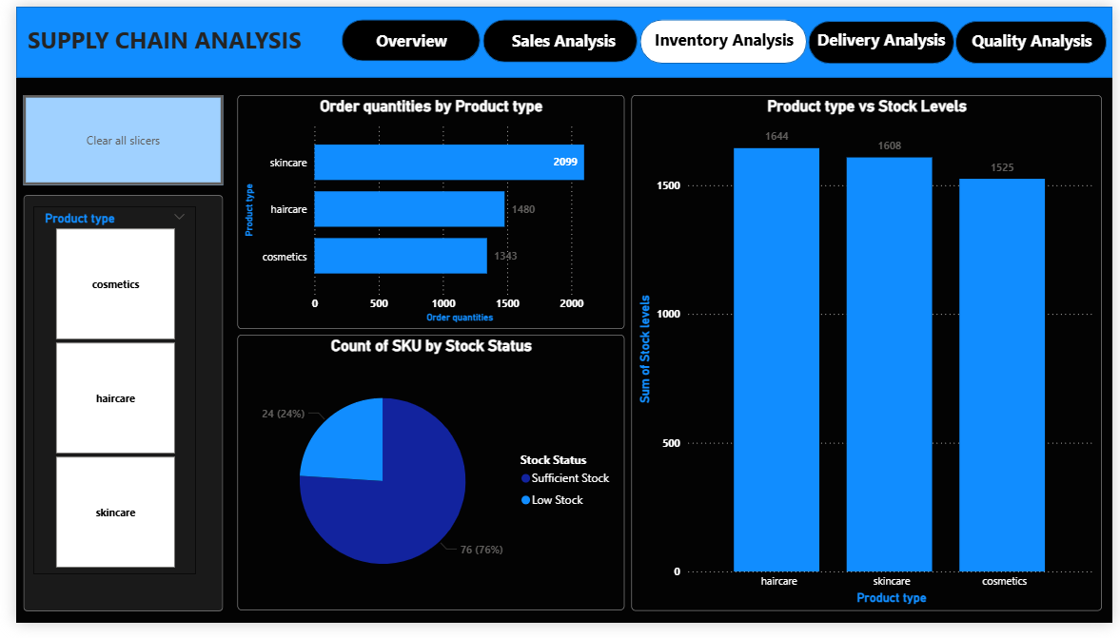
Fig 1.3

INVENTORY ANALYSIS – Insights:
Focus: This analysis evaluates stock availability and demand patterns.
- Inventory is generally well-managed, with 76% of products under sufficient stock, while 24% are categorized as low stock, indicating potential risk areas.
- Haircare products maintain the highest stock levels, ensuring availability, while other categories have relatively balanced stock.
- Skincare products show the highest order quantities 2099, aligning with their strong sales performance and demand.
- The analysis suggests that inventory planning should focus more on high-demand products to prevent stock shortages.

3.1.3 Delivery Analysis
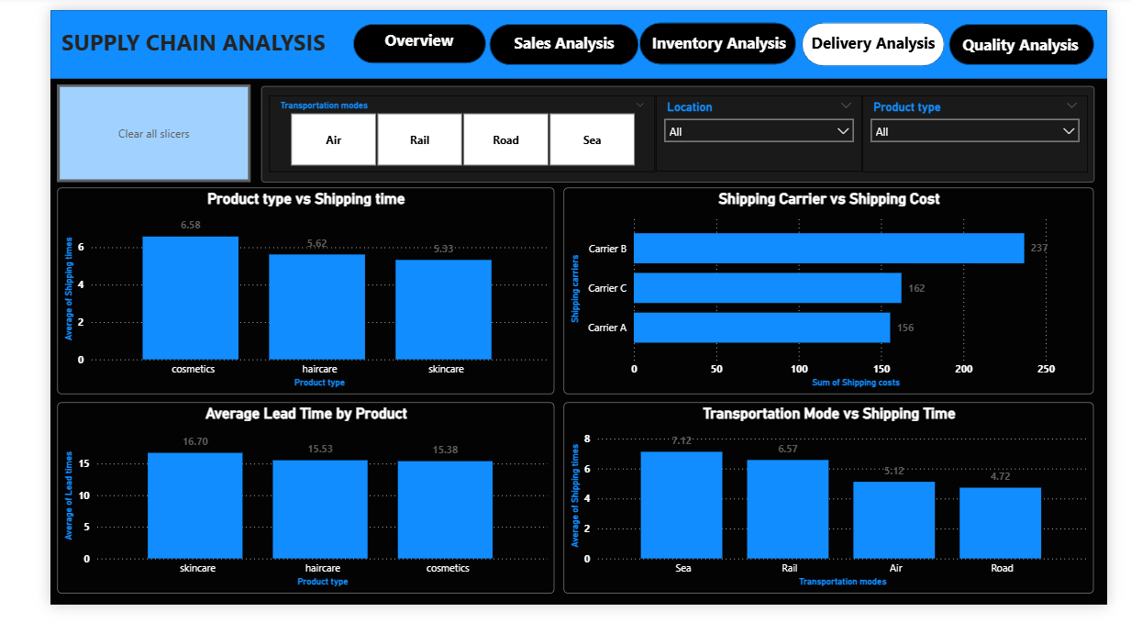
Fig 1.4
DELIVERY ANALYSIS – Insights:
Focus: This analysis examines delivery efficiency and logistics performance.
- Delivery performance varies across products, with cosmetics having the highest shipping time of 6.58 days, indicating slower delivery.
- Skincare products have relatively faster shipping time of 5.33 days, improving customer satisfaction.
- Skincare also has the highest lead time of 16.7 days, suggesting longer production or processing duration.
- Among shipping carriers, Carrier B is the most expensive, while Carrier A is more cost-efficient.
- Transportation mode significantly impacts delivery, where road transport is the fastest (4.7 days), while sea transport is the slowest (7.1 days) but more economical.

3.1.4 Quality Analysis
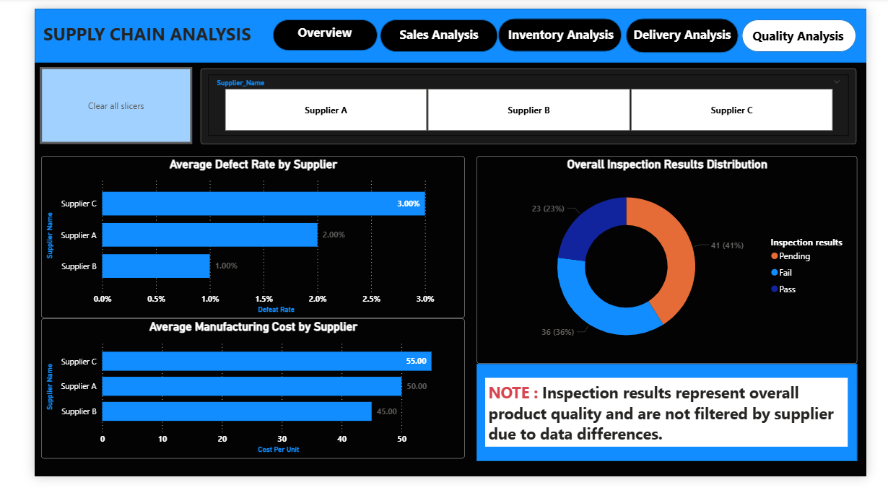
Fig 1.5

QUALITY ANALYSIS – Insights:
Focus: This section focuses on supplier performance and product quality.
- Supplier performance shows clear variation, where Supplier C has the highest defect rate (3%), while Supplier B has the lowest (1%), making it the most reliable supplier.
- In terms of cost and quality, Supplier C has the highest manufacturing cost (55 INR) but also the highest defect rate, indicating that higher cost does not guarantee better quality.
- The inspection results reveal that 41% of products are pending, 36% have failed, and only 23% have passed, highlighting inefficiencies in the quality control process.
- Overall, the analysis indicates the need for better supplier selection and improved quality inspection processes.

CHAPTER – 4: RESULTS AND CHALLENGES

4.1 Key Insights
- Skincare is the top-performing product category in terms of both sales and revenue.
- A small number of SKUs contribute significantly to total revenue, indicating key revenue drivers.
- Inventory management is generally stable, but 24% of products are at risk of low stock.
- Delivery efficiency varies across products, with cosmetics facing delays.
- Transportation mode plays a critical role in cost and delivery speed, requiring balance between efficiency and cost.
- Supplier performance varies significantly, with Supplier B performing best and Supplier C showing quality issues.
- Higher manufacturing cost does not guarantee better product quality.

4.2 Business Recommendations
- Focus on Skincare products to maximize revenue and growth.
- Promote and increase production of top-performing SKUs.
- Improve inventory planning to avoid low stock situations.
- Optimize logistics by balancing cost and delivery speed.
- Use Sea transport for cost savings when delivery is not urgent.
- Reduce dependency on Supplier C due to higher defect rate.
- Prefer Supplier B for better quality and cost efficiency.
- Negotiate with high-cost carriers (e.g., Carrier B).
- Improve inspection processes to reduce pending and failed products.

4.3 Challenges Faced
- Supplier data had inconsistent naming conventions across tables (Supplier 1–5 vs Supplier A–C), making it difficult to establish relationships.
- Due to this, supplier-related analysis had to be handled separately.
- Initial difficulty in understanding and creating DAX measures.
- Effort was required in structuring and preparing the dataset for analysis.
- Designing an effective and user-friendly dashboard was challenging.

4.4 Key Learnings
- Gained hands-on experience in Power BI dashboard creation.
- Improved understanding of supply chain concepts.
- Learned data cleaning and transformation techniques.
- Developed analytical and problem-solving skills.

CHAPTER – 5: CONCLUSION

5.1 Conclusion
The supply chain analysis provided valuable insights into business performance across sales, inventory, delivery, and quality. The Power BI dashboard enabled effective visualization and comparison of different aspects of the supply chain.
The findings highlight key areas for improvement, particularly in delivery efficiency and supplier performance. Implementing the recommendations can help enhance operational efficiency and overall business performance. This project demonstrates the importance of data-driven decision-making in improving supply chain efficiency.

